**Task-2**

**VPN Gateways and Vnet Peering**

Creating a Vnet1 in a Resource Group along with front end subnet.

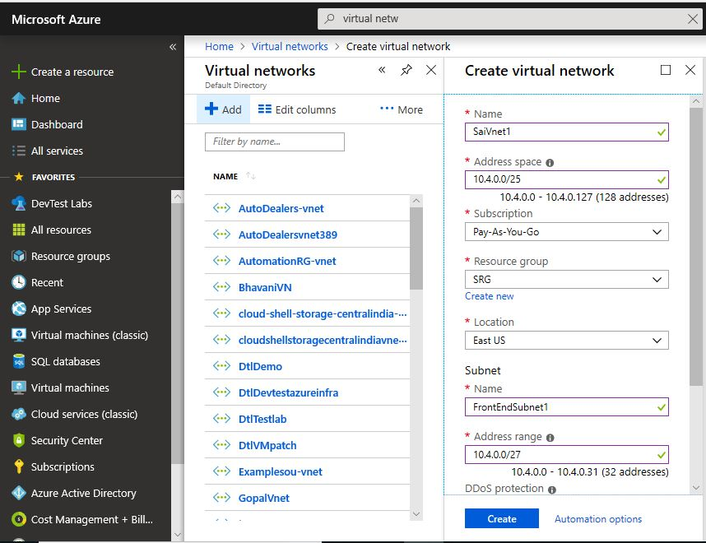

Creating a Gatewaysubnet1 in the Vnet1

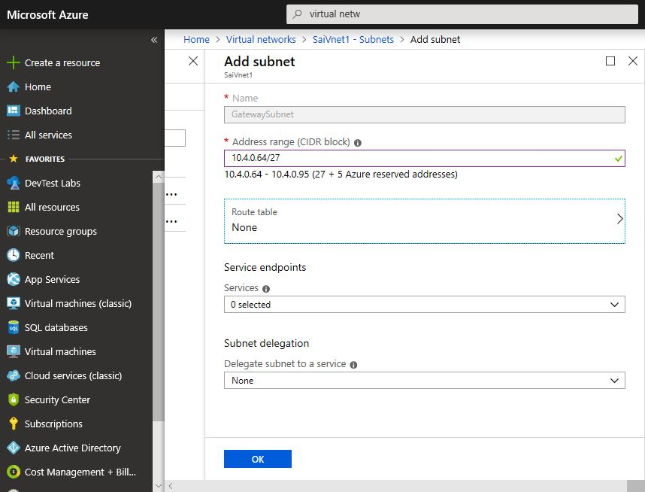

Creating a Vnet2 along with frontendsubnet2 in the same resource group as vnet1

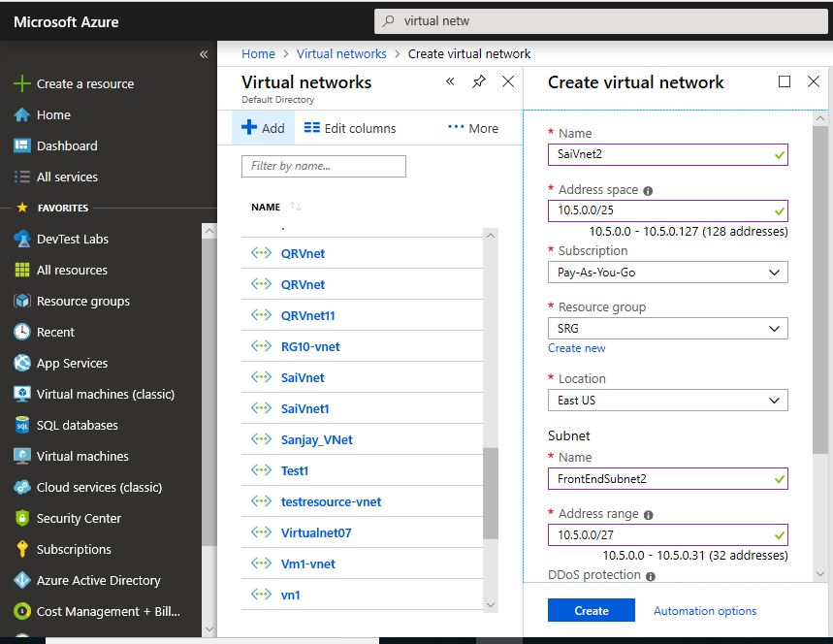

Creating a Backendsubnet2 for Vnet2

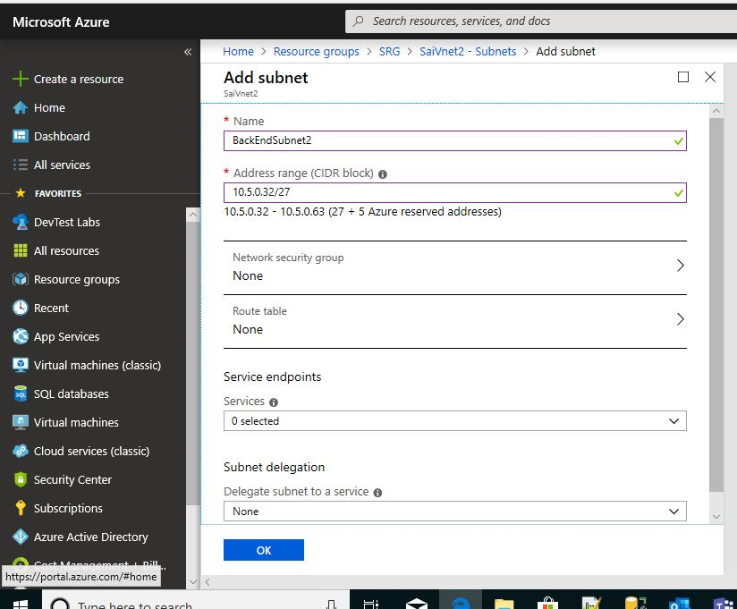

Creating a Gateway subnet to Vnet2

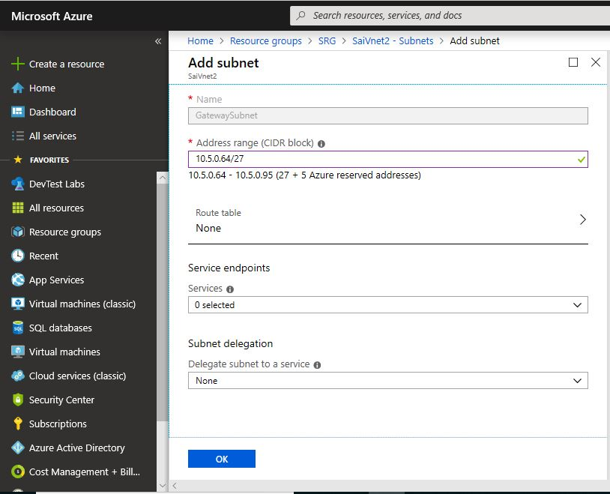

Creating a Vnet3 along with frontendsubnet3

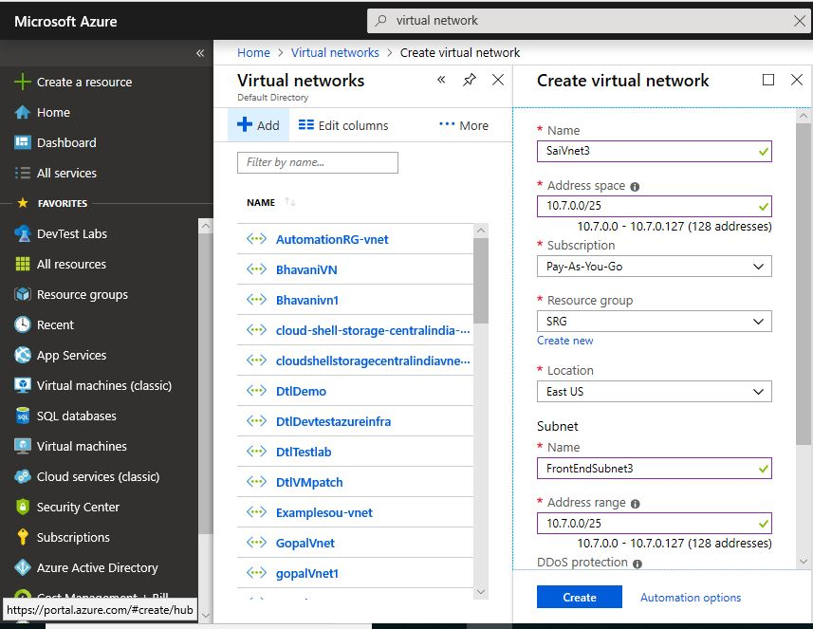

Create a backend subnet3 to vnet3

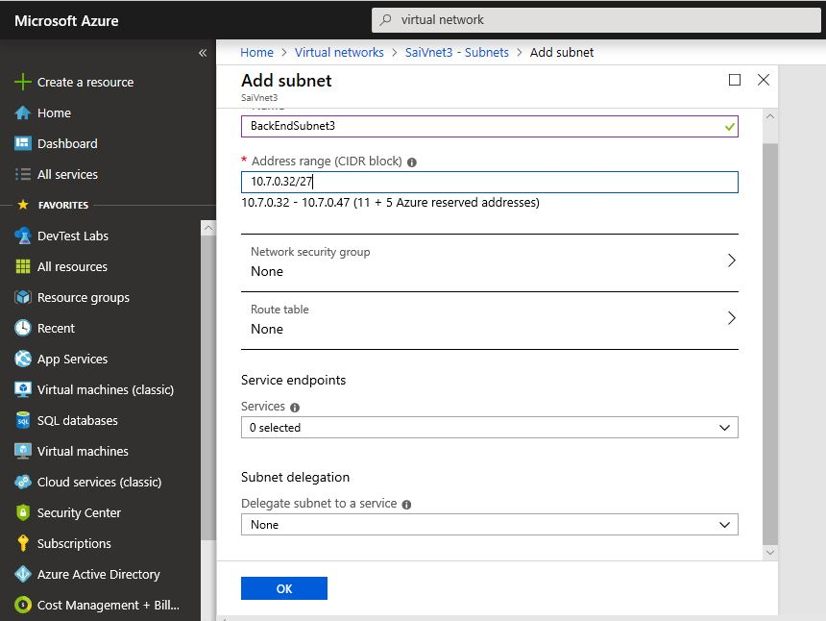

Creating a Gatewaysubnet3 to vnet3

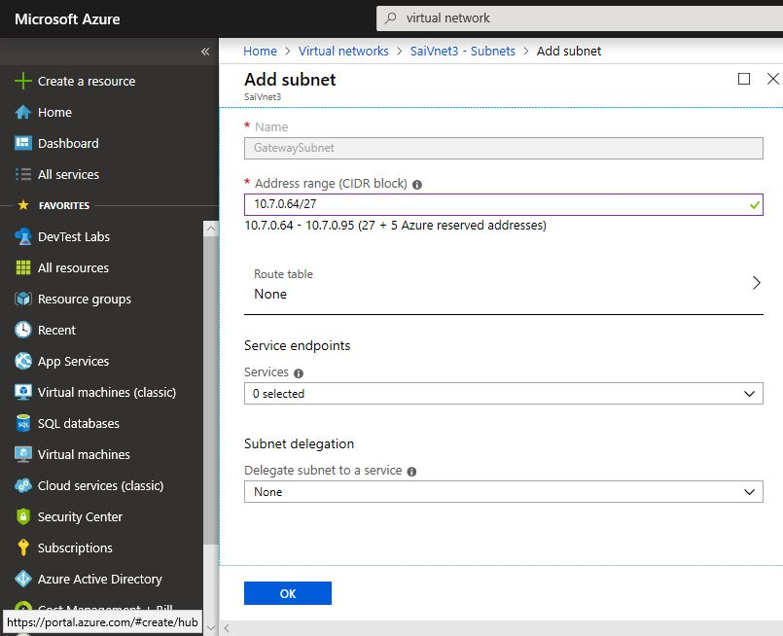

Adding a VPNGateway1 to Vnet1

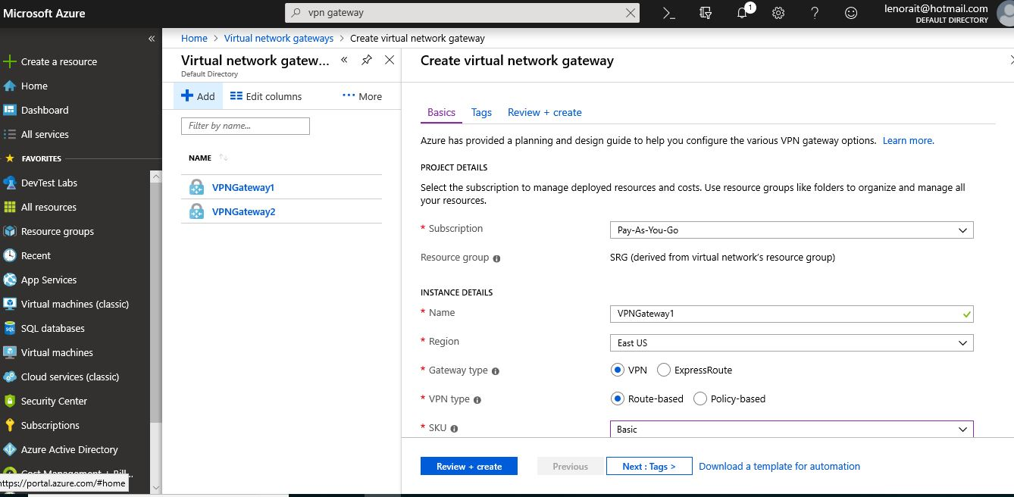

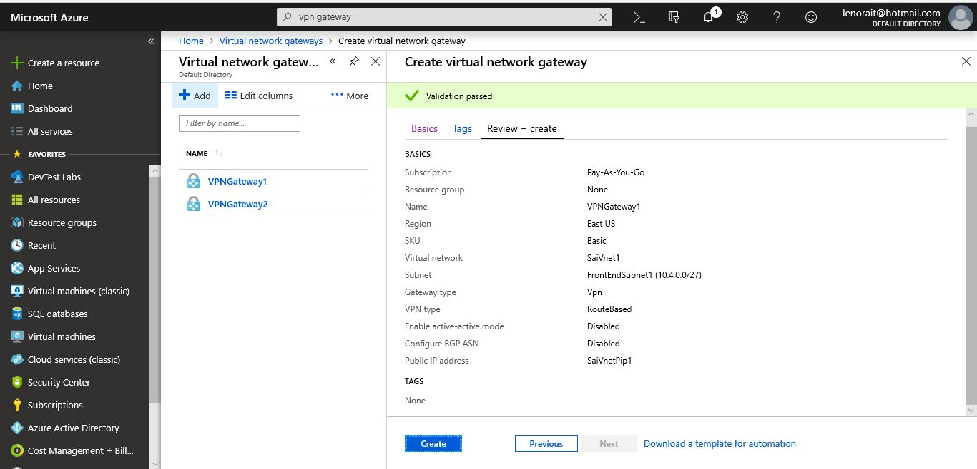

Adding VPNGateway2 to Vnet2

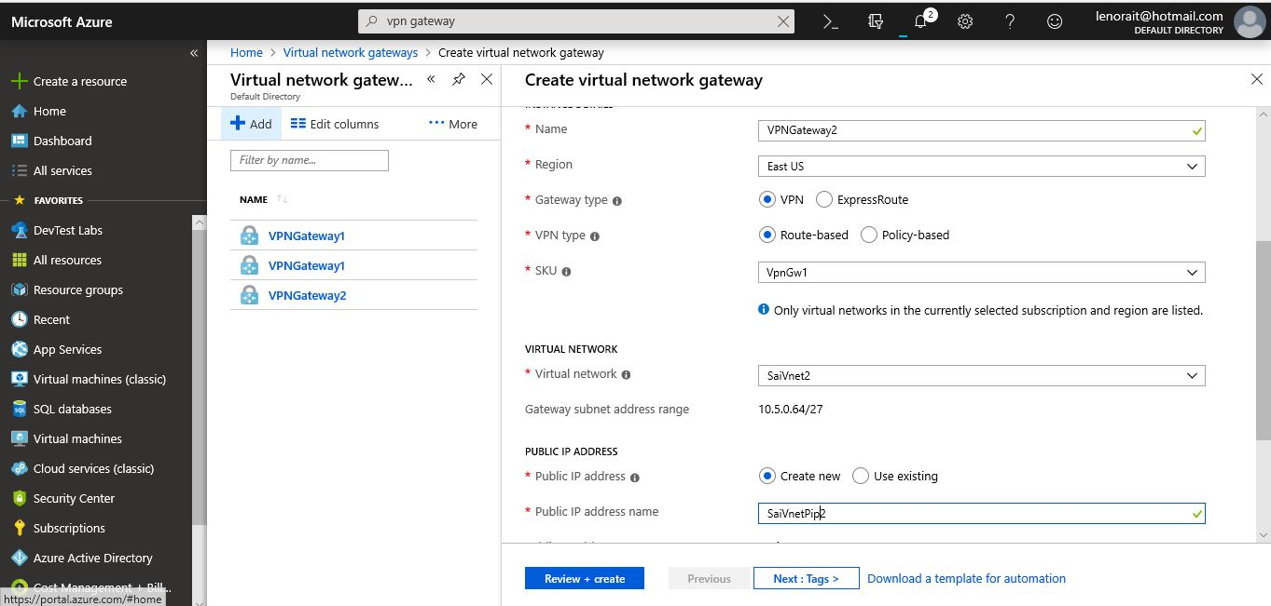

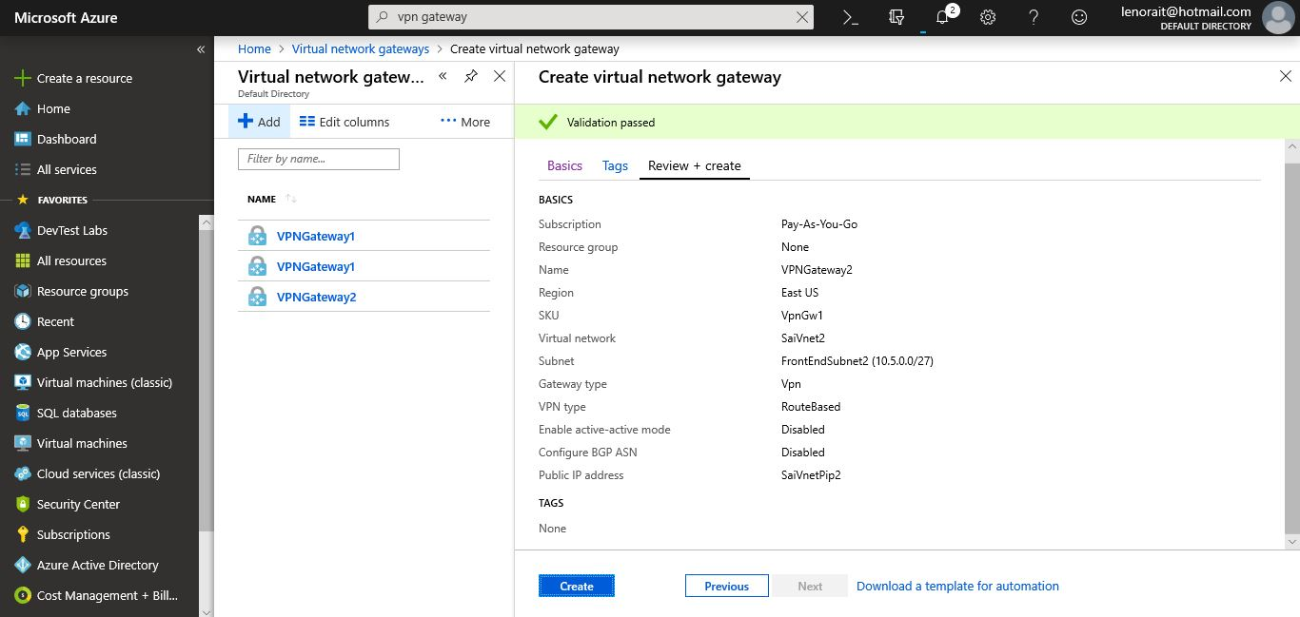

Establishing VPN Gateway Connection from VPNGateway1 to VPNGateway2

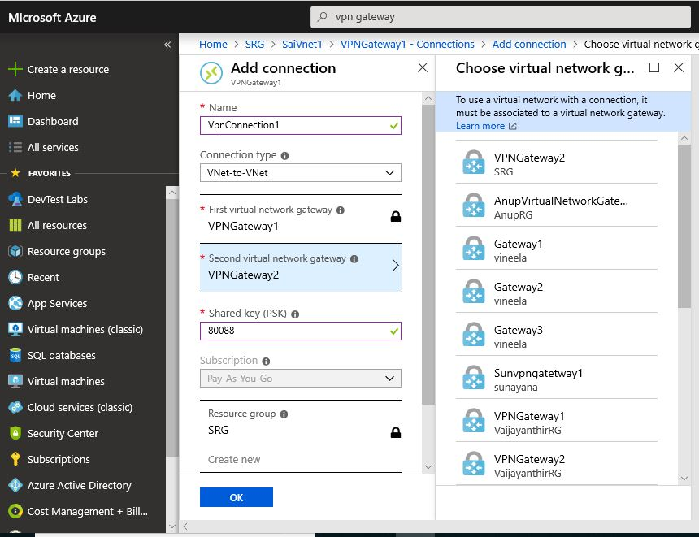

Establishing VPN Gateway Connection from VPNGateway2 to VPNGateway1

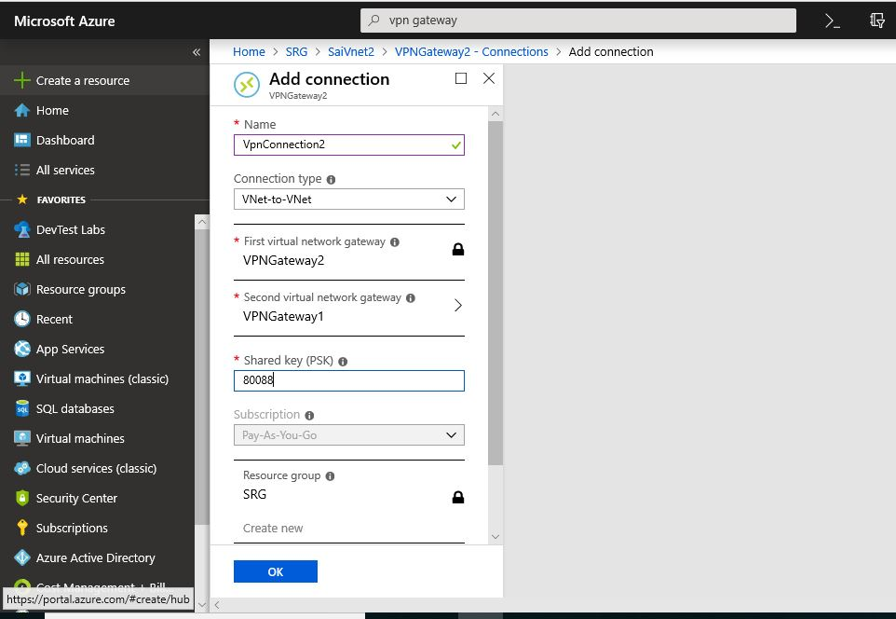

After Connecting VPNGateway1&2 Peer Vnet2-Vnet3 and make Vnet2 as Hub

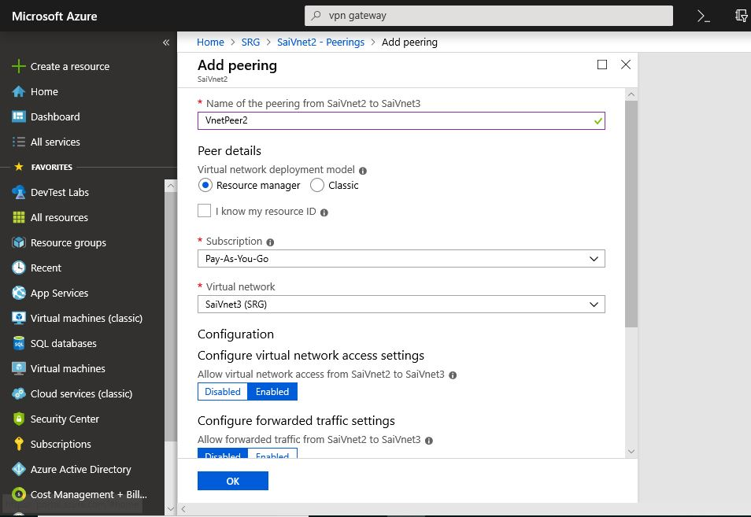

After Connecting VPNGateway1&2 Peer Vnet3-Vnet2 and make Vnet3 as Spoke

